**Internet Protocols - Static and Dynamic Addresses**

### Scenario

Your role is a cloud support engineer at Amazon Web Services (AWS). During your shift, a customer from a Fortune 500 company requests assistance regarding a networking issue within their AWS infrastructure. The email and an attachment of their architecture is below:

### Ticket from your customer

Hello Cloud Support!

We are having issues with one of our EC2 instances. The IP changes every time we start and stop this instance called Public Instance. This causes everything to break since it needs a static IP address. We are not sure why the IP changes on this instance to a random IP every time. Can you please investigate? Attached is our architecture. Please let me know if you have any questions.

Thanks! Bob, Cloud Admin

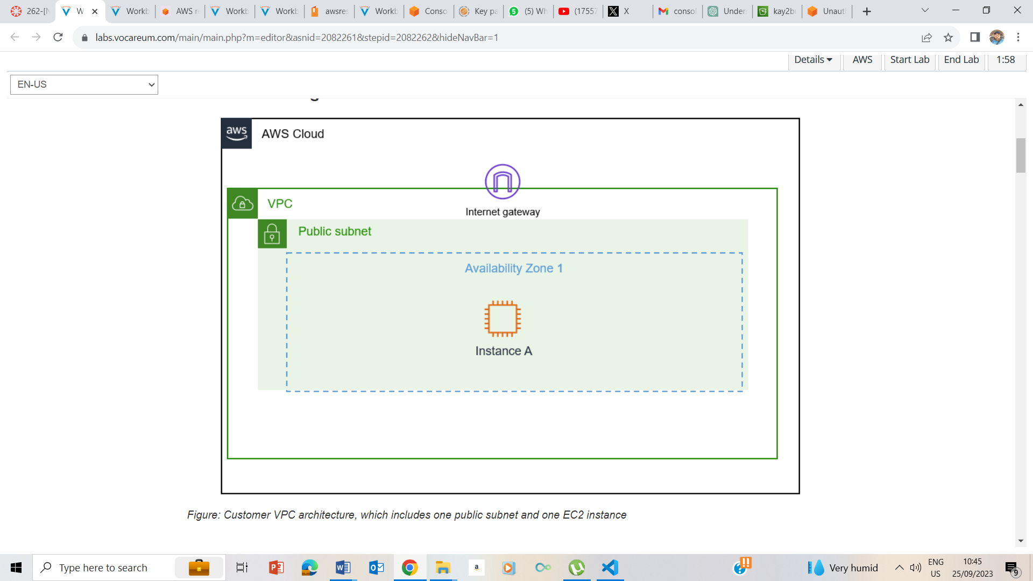

Figure: Customer VPC architecture, which includes one public subnet and one EC2 instance

## Accessing the AWS Management Console

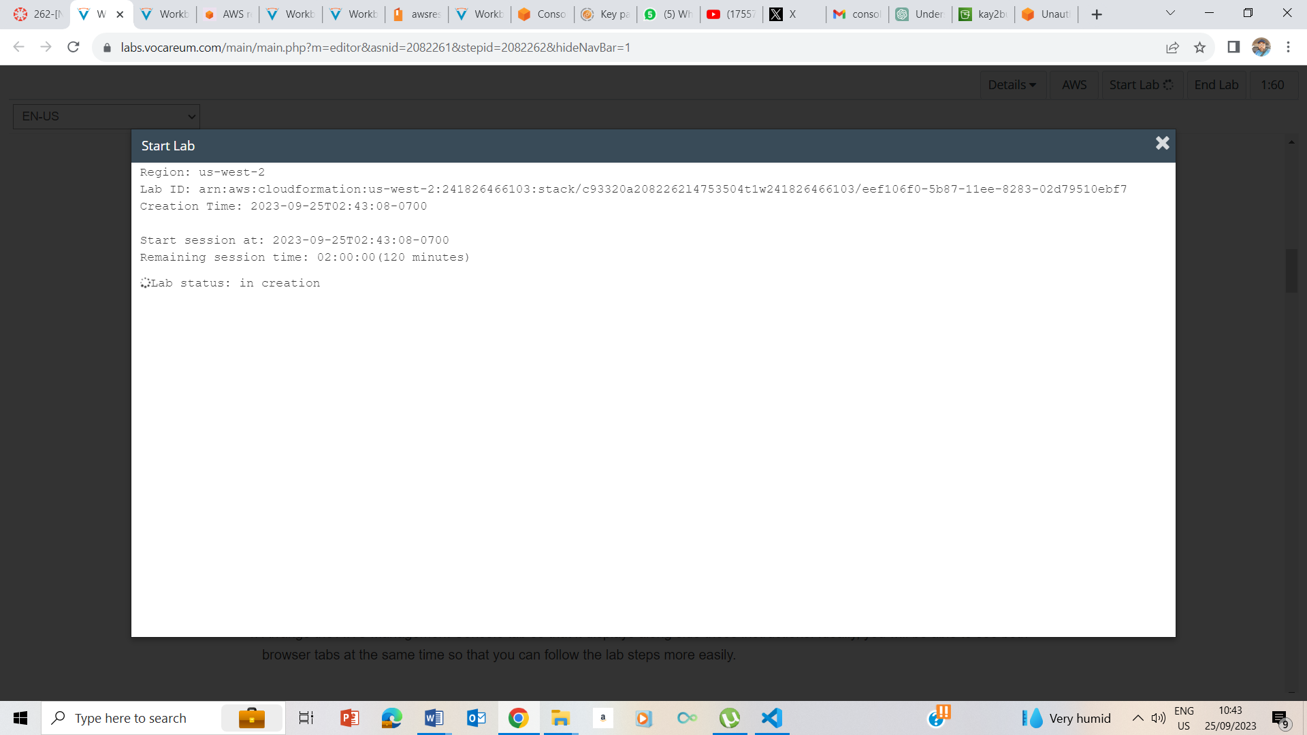

I clicked on Start button to begin the Lab and upon showing ready, I clicked the x

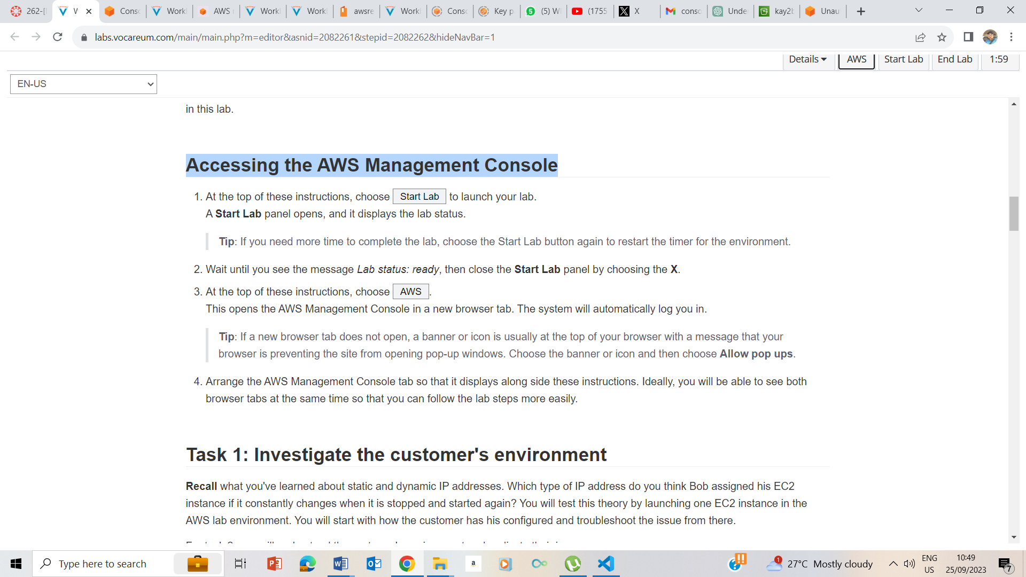

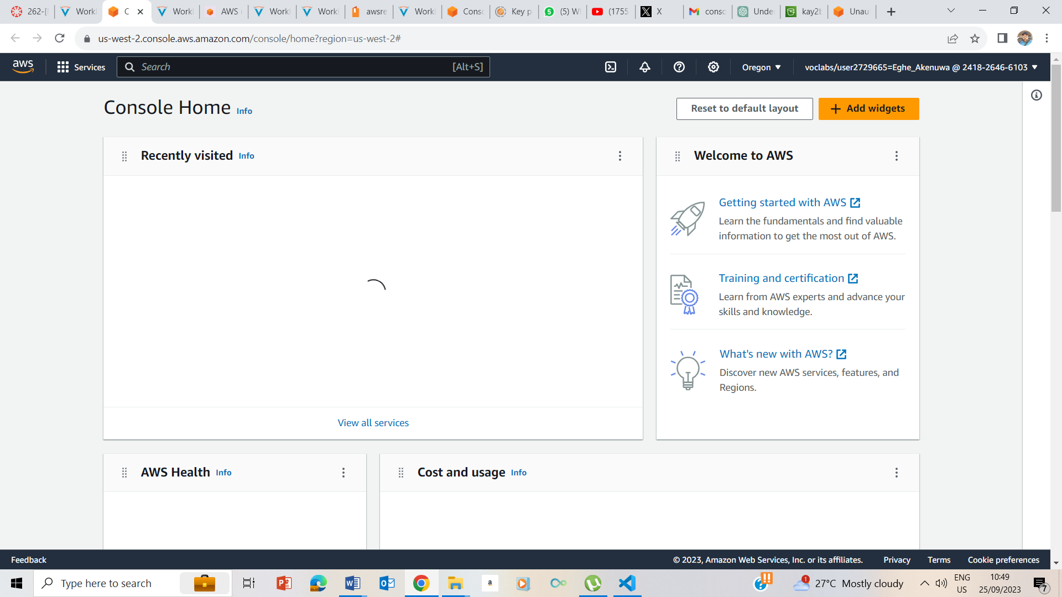

I clicked on the AWS button to take me to the AWS management console.

## Task 1: Investigate the customer's environment

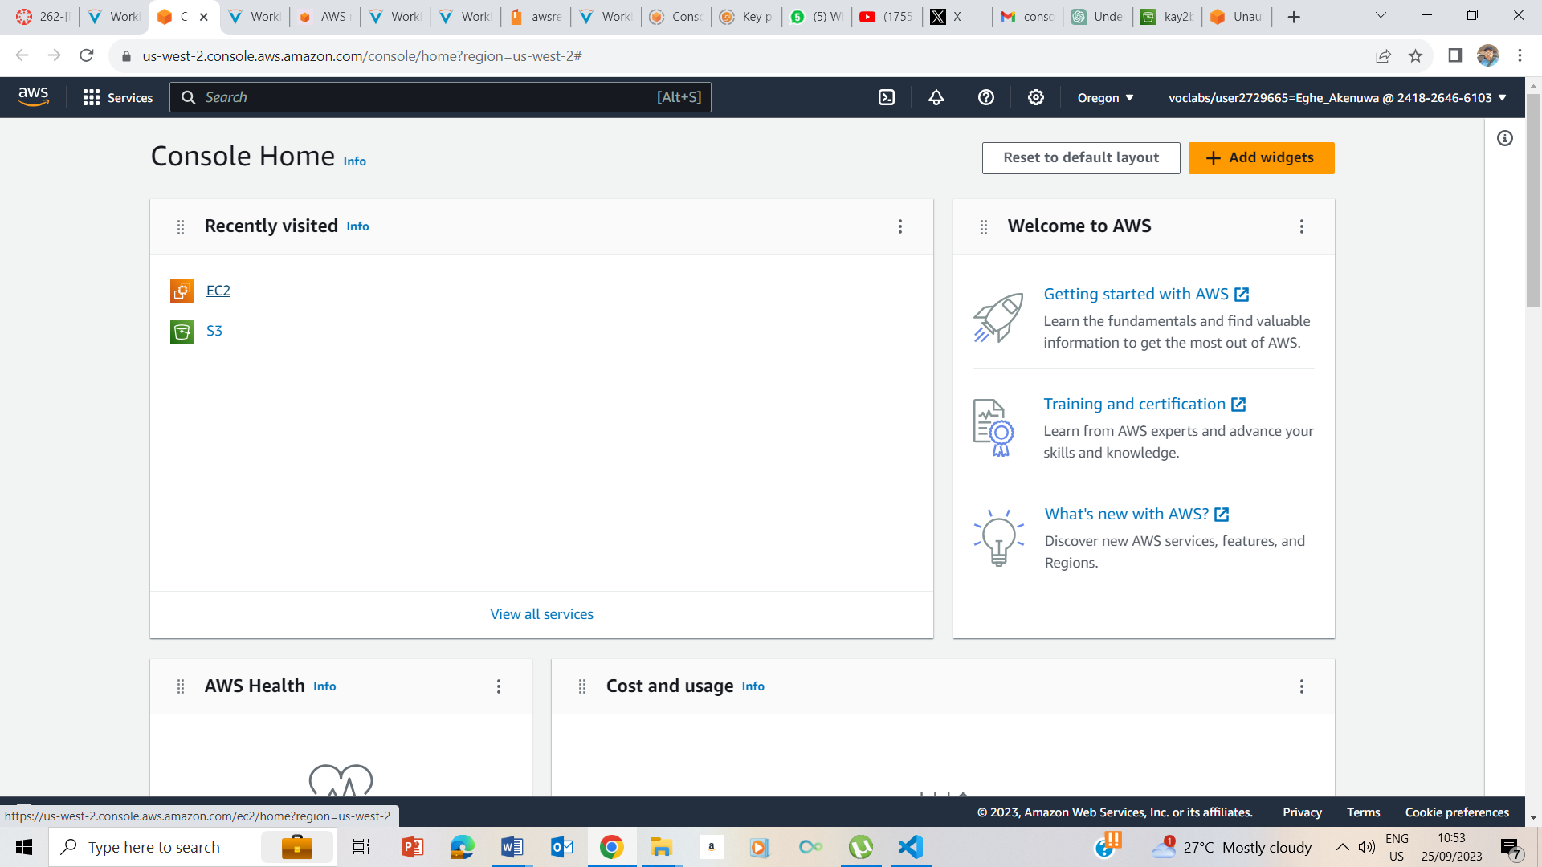

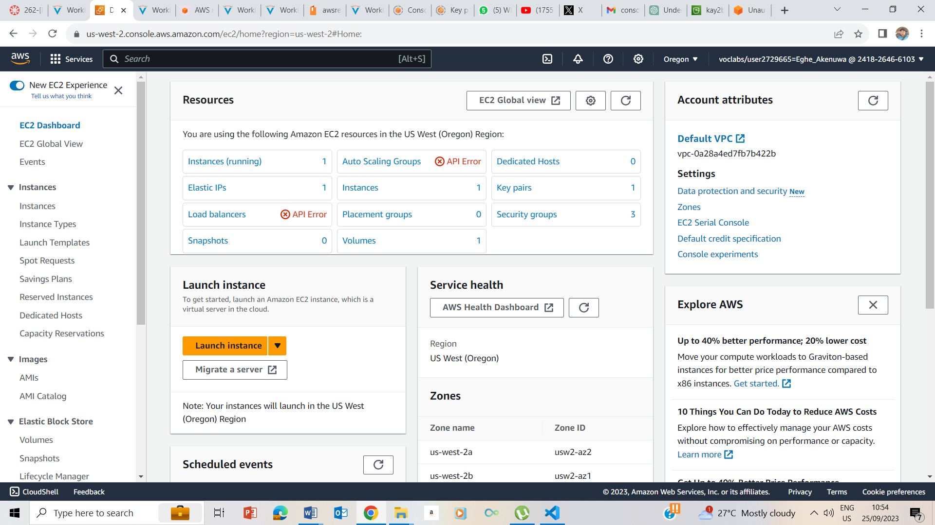

Clicked on the EC2 to take me to EC2 page

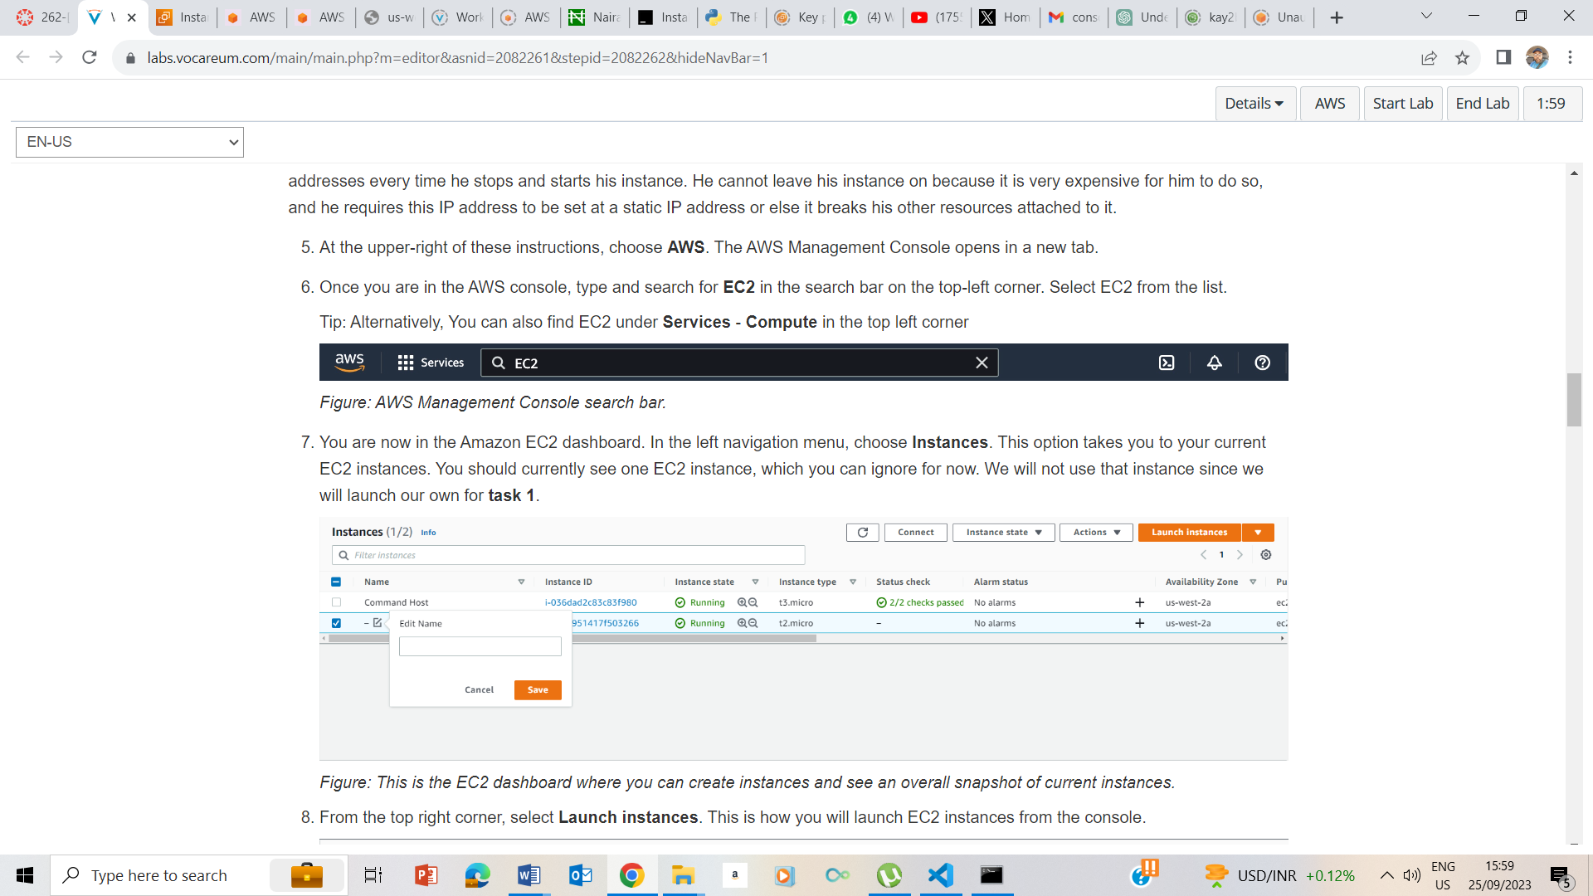

Clicked on Instances and launched Instances

**Step 1: Choose an Amazon Machine Image (AMI)**:

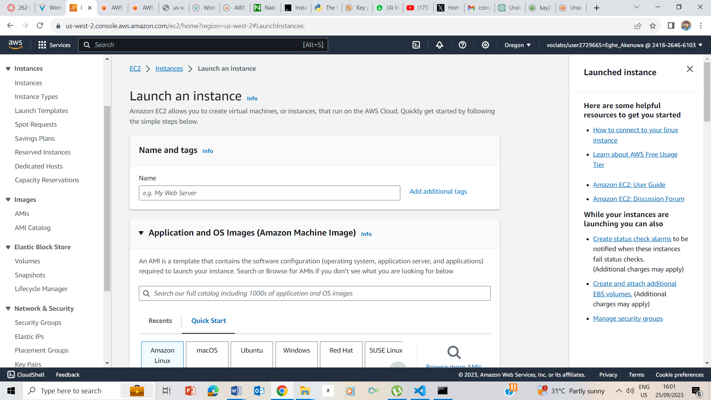

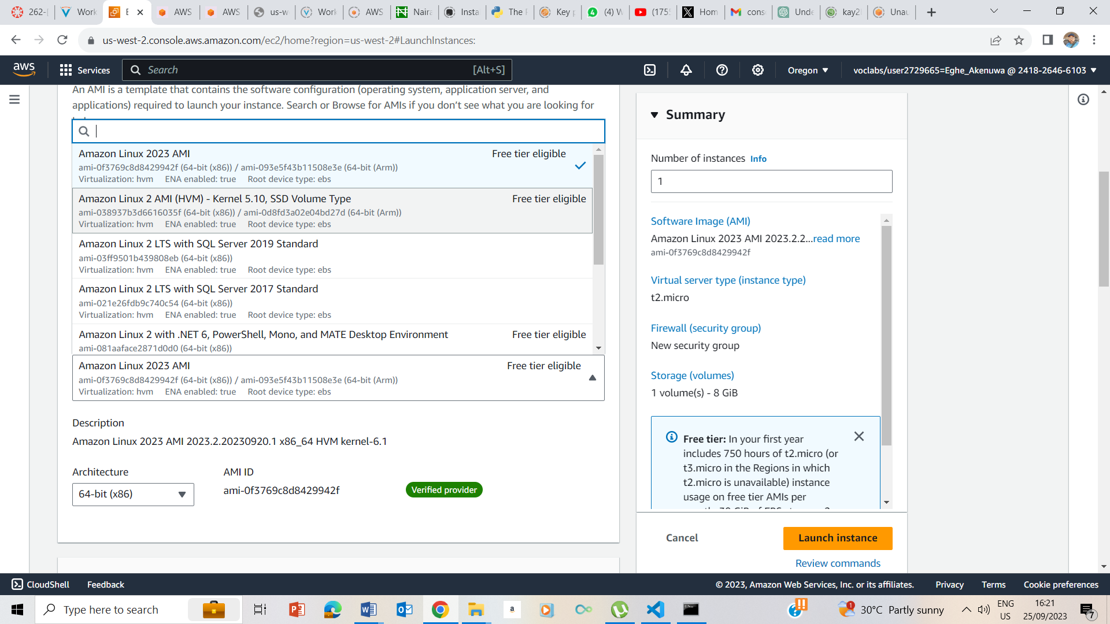

Selected Amazon Linux 2 AMI as the AMI

**Step 2: Choose an Instance Type**:

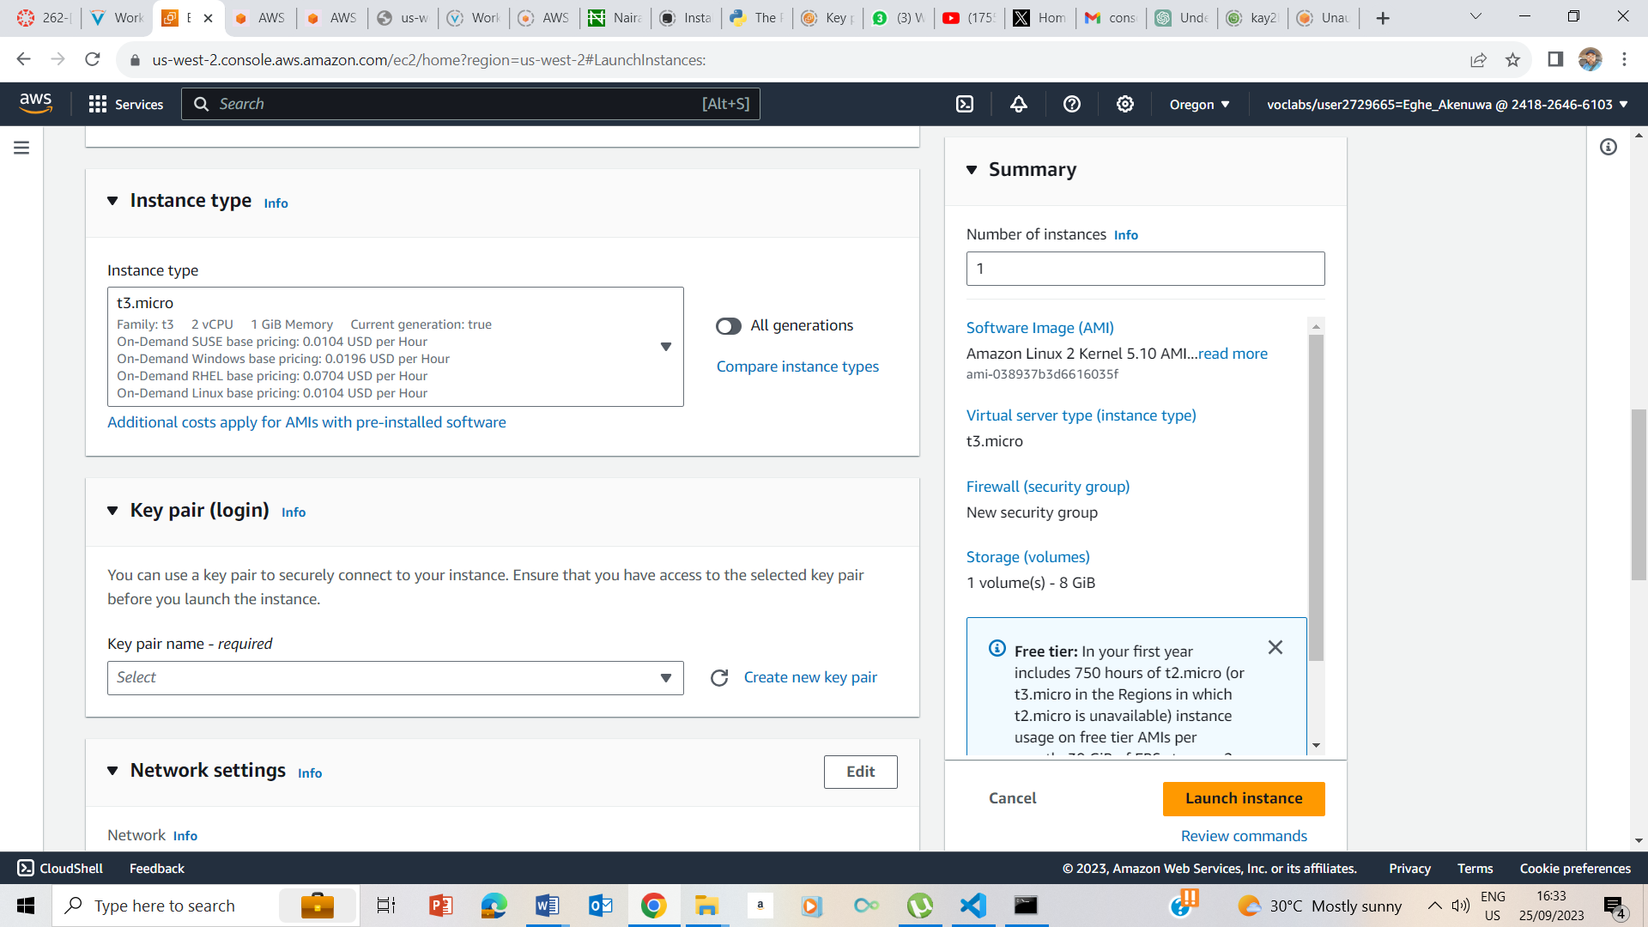

osed t3.micro as the instance type

**Step 3: Configure Instance Details**:

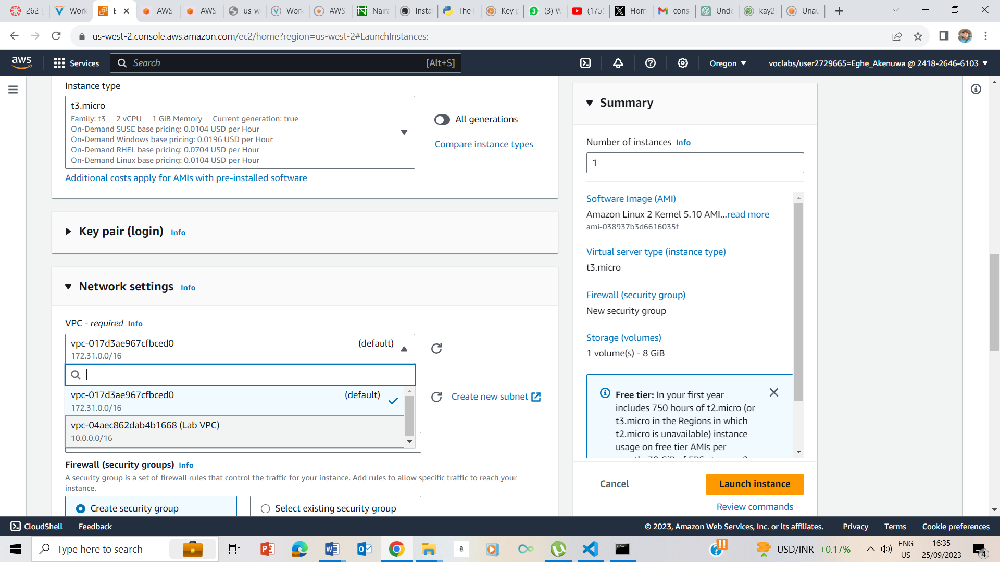

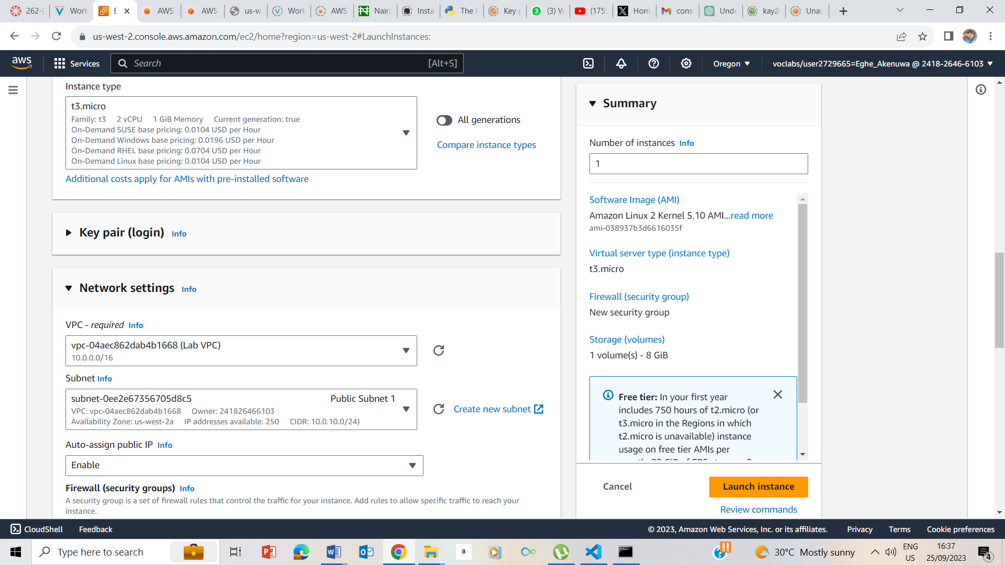

Choosed VPC and recommended subnet

**Step 4: Add Storage**: Leave as default

**Step 5: Add Tags**:

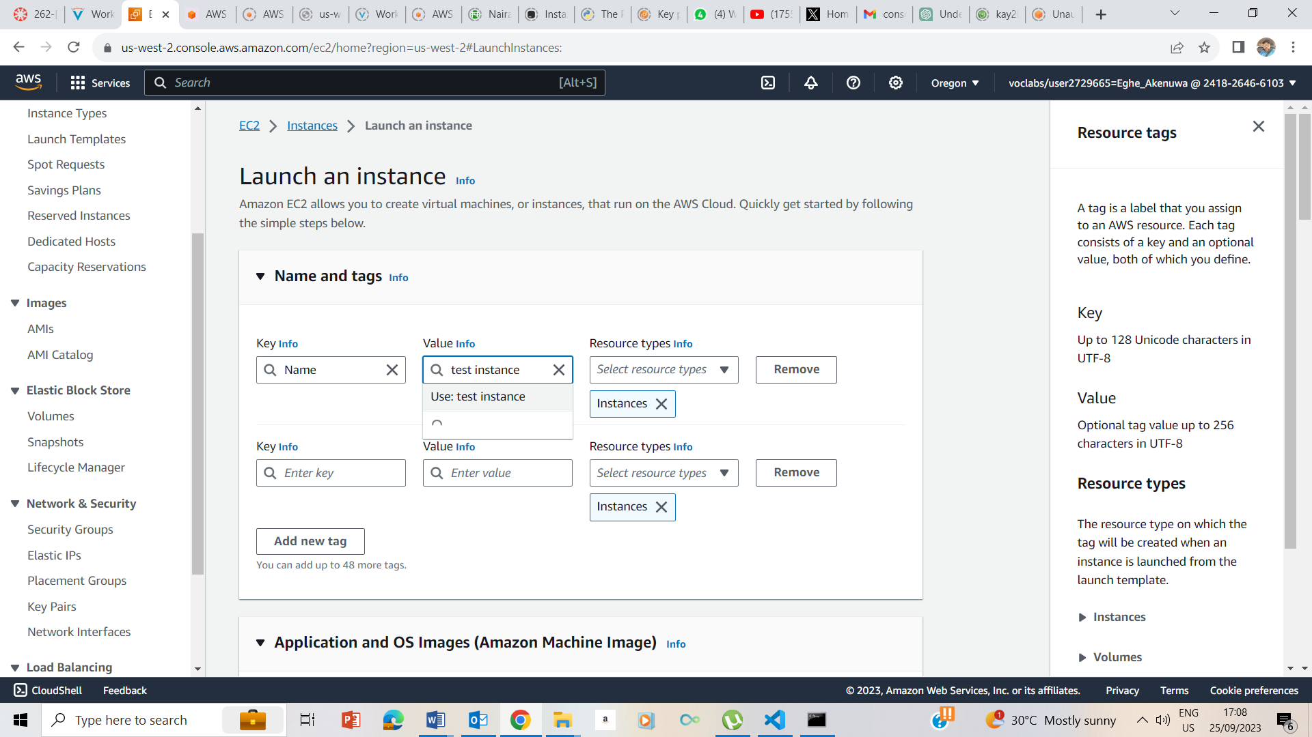

Under Name, we choosed Name, and under value, I entered test instance

**Step 6: Configure Security Group**:

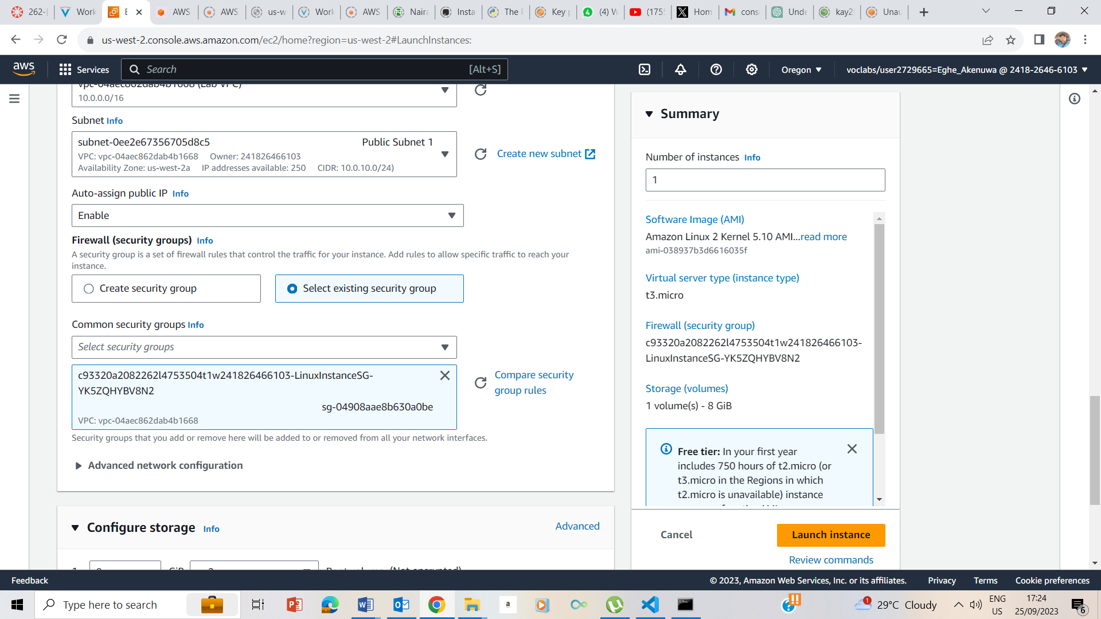

Selected Linux instance SG

**Step 7: Review Instance Launch**:

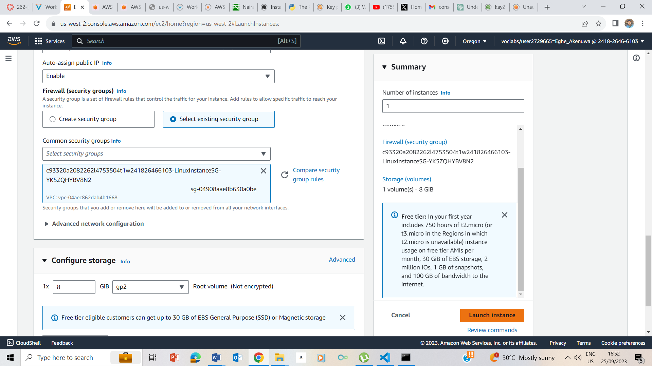

Key pair

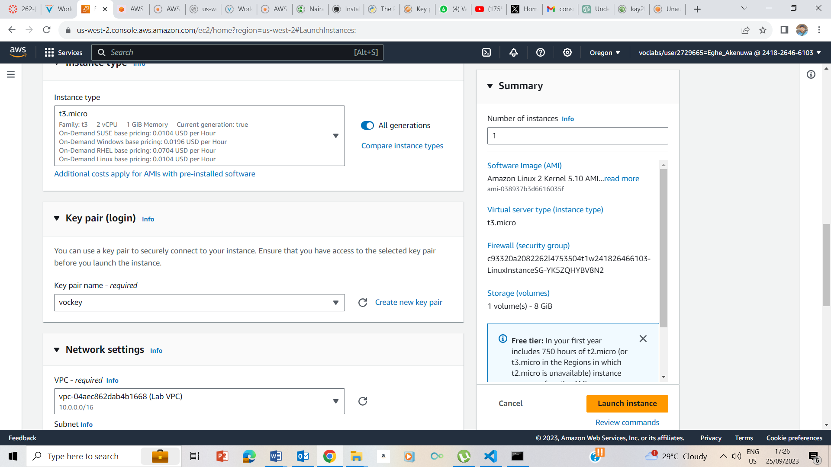

Launch success

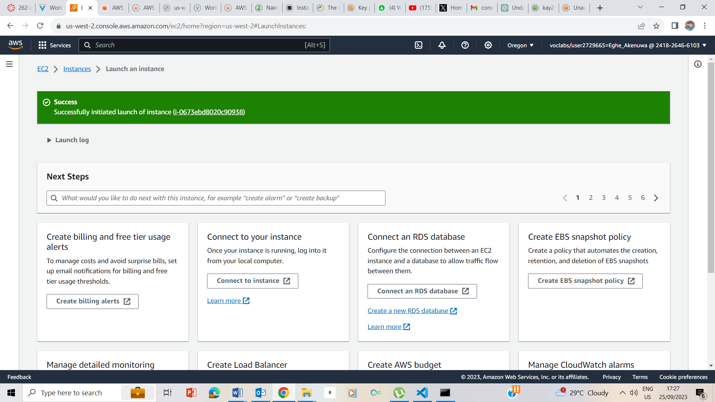

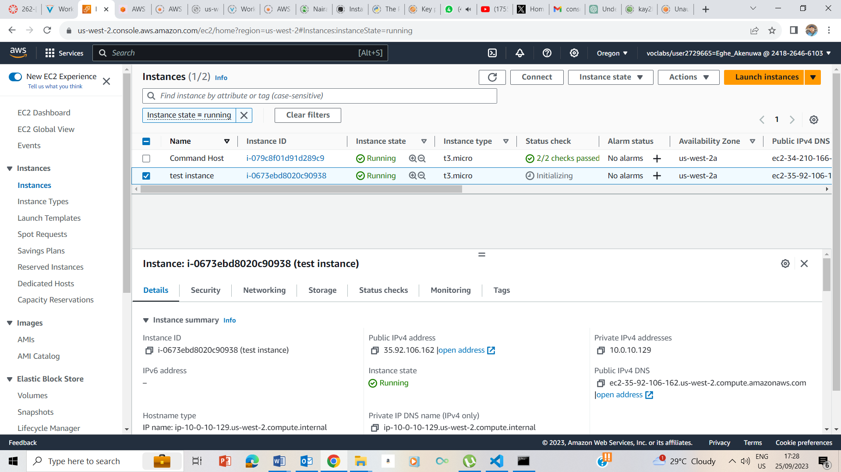

Noted the public ipv4 and private ipv4

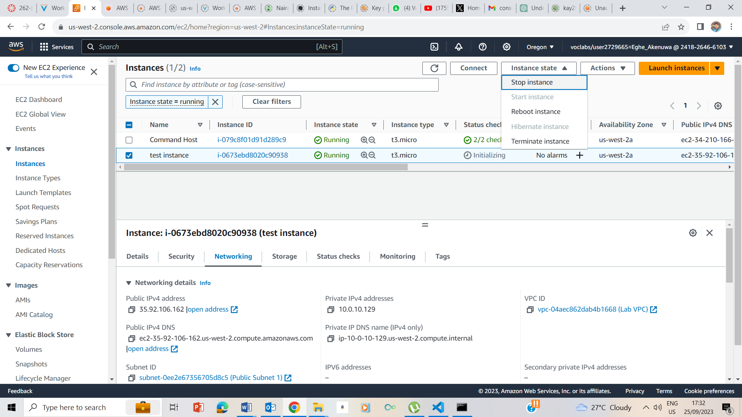

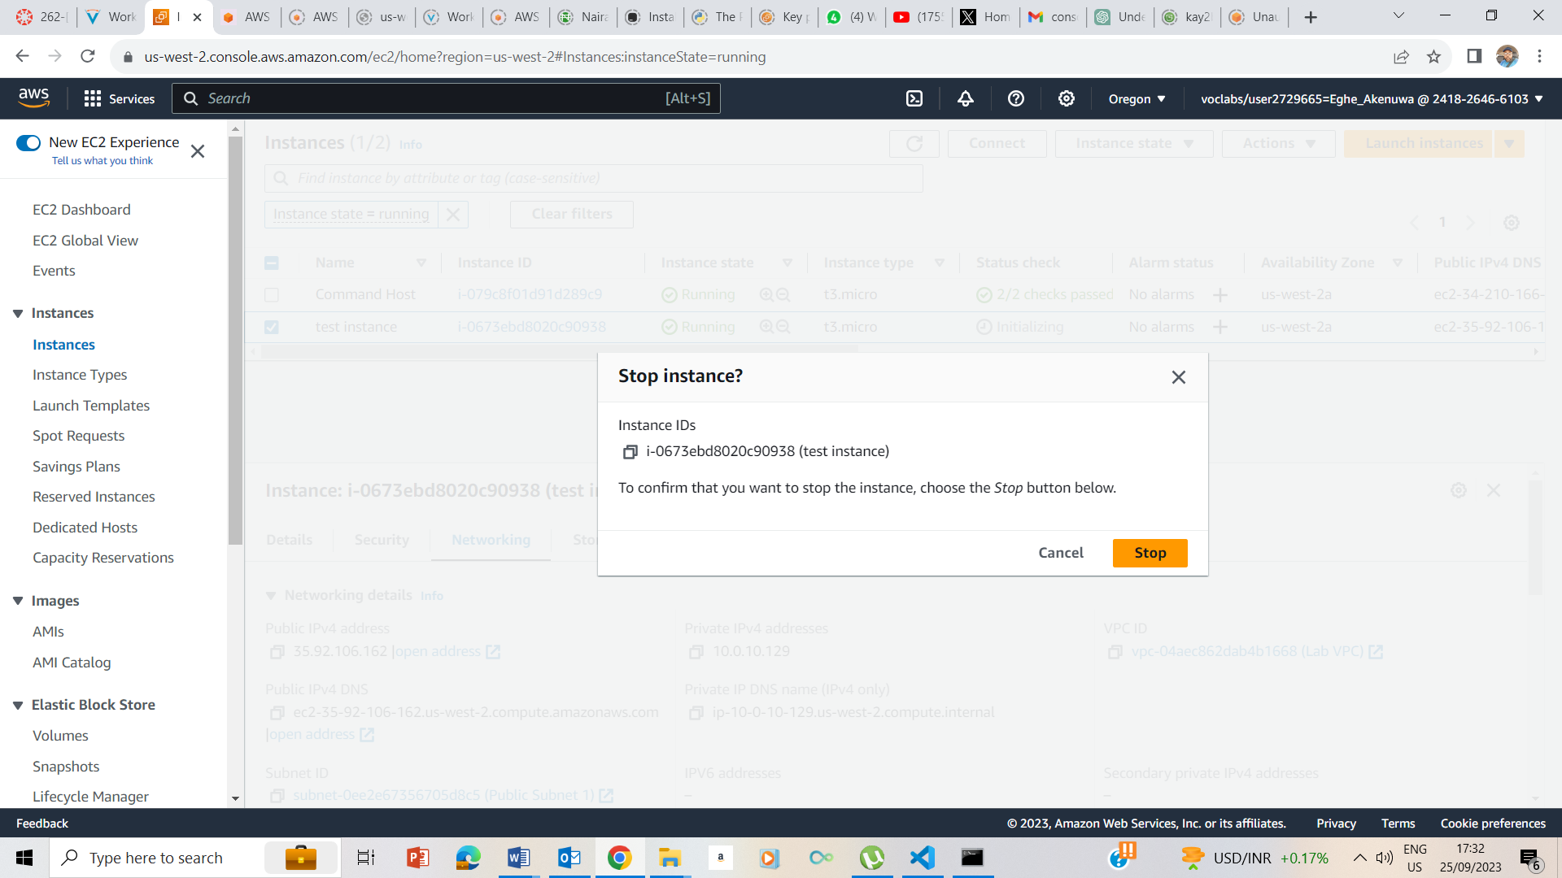

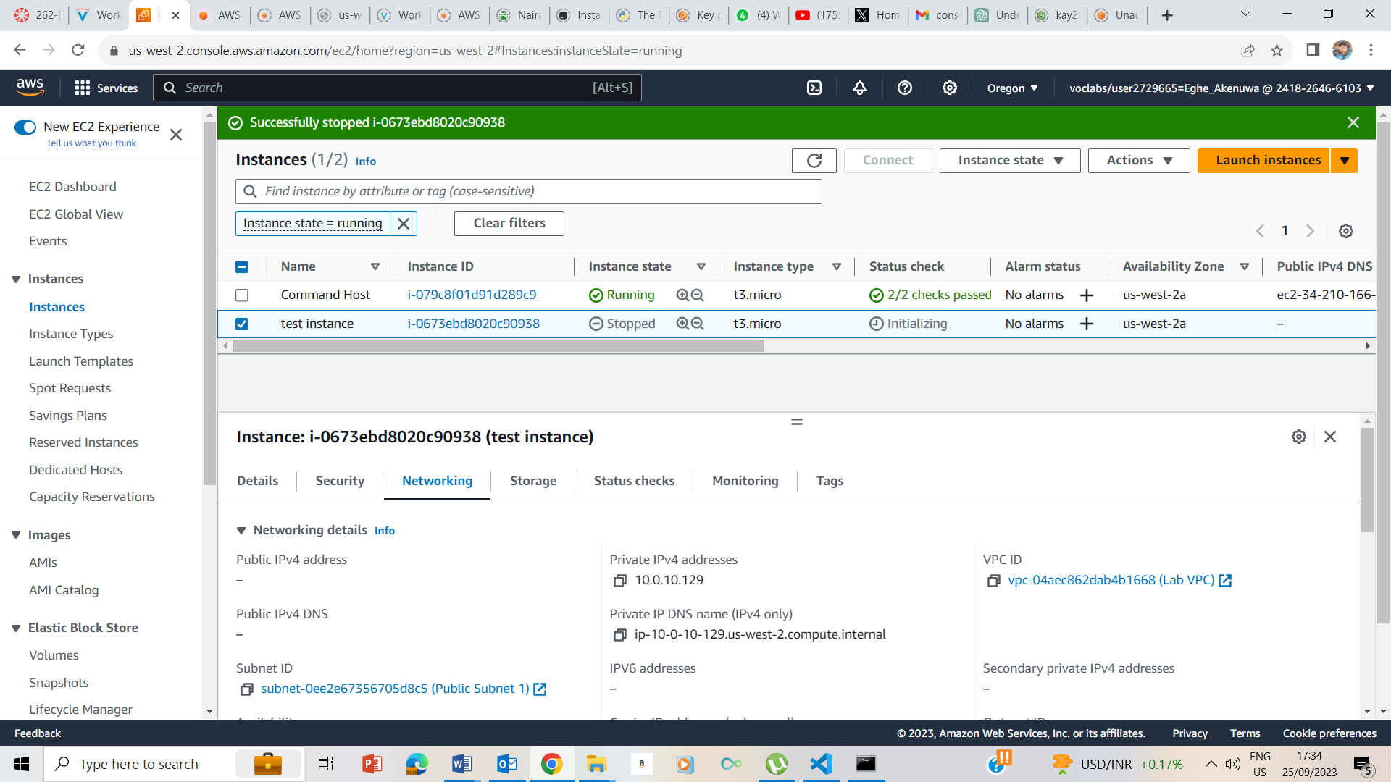

After Instane state was stopped, public ipv4 and private ipv4 was no longer available

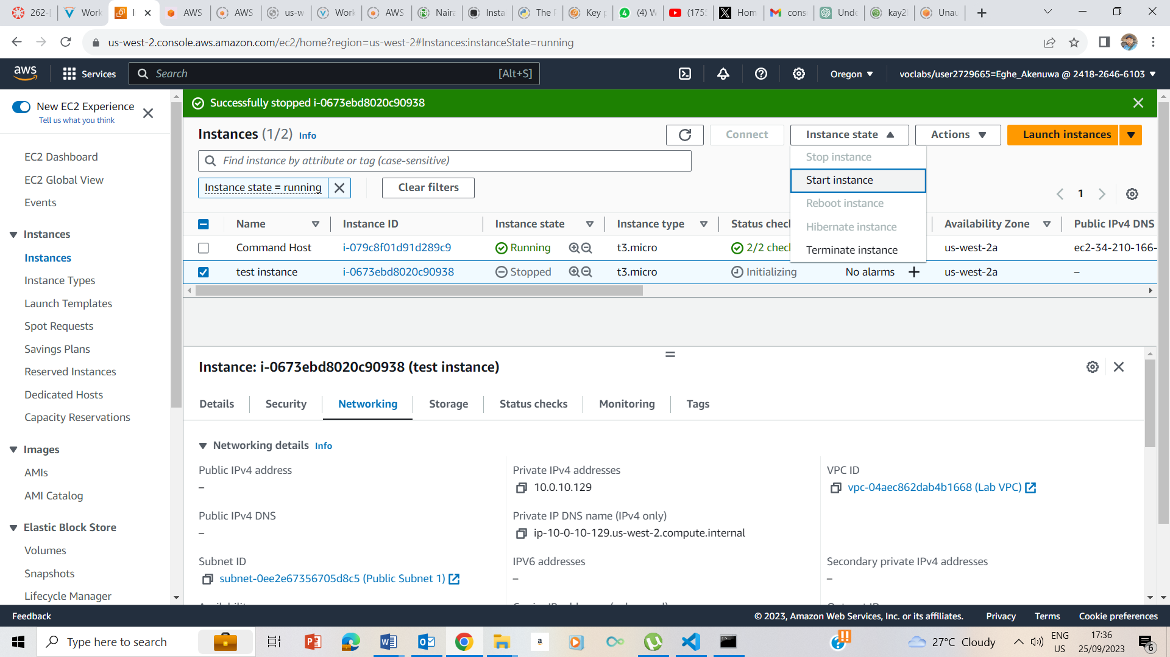

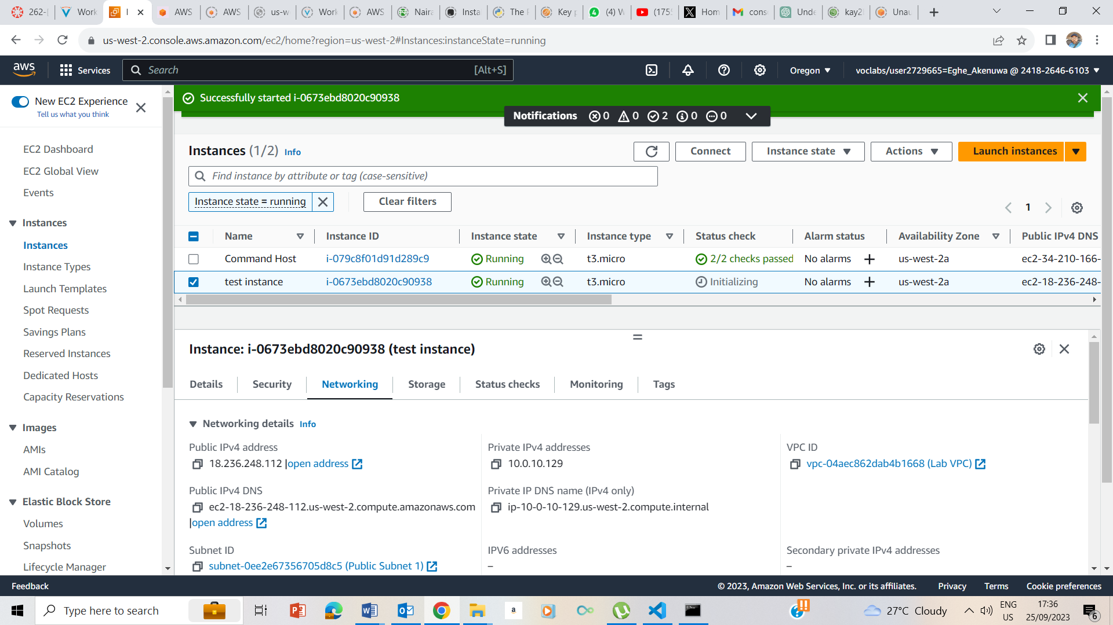

Instance State Start

Noted that the Public Ipv4 address has changed